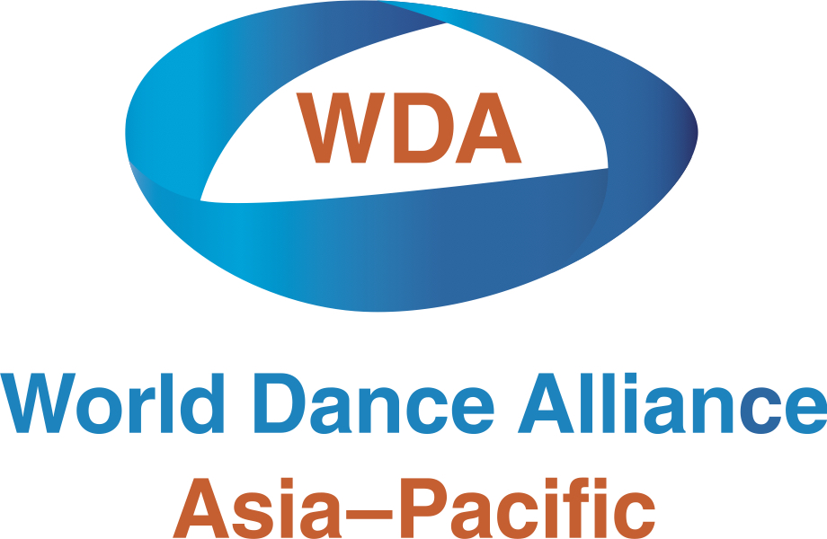

“Begin Again” – Small Grants for Individual Dance Makers

BACKGROUND
In these challenging times, dancers and choreographers in Bangladesh and India have undergone a particularly harsh struggle. Not only have they coped with loss of livelihood, but also with the huge anxiety and suffering that accompanied the recent wave of COVID-19 illness and death across the subcontinent.

OVERVIEW
“Begin Again” Small Grants for Individual Dance Makers is a collective initiative of the World Dance Alliance Asia-Pacific (WDAAP) and international dance enthusiasts. It will support young and emerging dancers and choreographers from India and Bangladesh impacted by COVID-19 pandemic, and aims to:

- Encourage dance makers and choreographers to “Begin Again” and continue their work, despite challenging circumstances.
- Provide funding for young, emerging dancers/choreographers to “kick start” their creativity and innovation and to push the boundaries of their artistic practice.
- Connect dancers & choreographers with each other for peer review and feedback.
- Enable dance artists to showcase their work to the world through digital channels and platforms while pandemic measures and limitations are in place.

OUTCOME
Each of the ten successful applicants will receive:
- USD $300 to put towards the development of a new dance work: a 2-3 minute dance video, in any genre, solo or group, filmed and presented as one continuous take.
- Peer review and feedback for the development of the dance video.
- Showcase of the dance video at SWEAT Festival in Hong Kong during the World Dance Alliance Global Summit events from 22-24 Jun 2022.

ELIGIBILITY & REQUIREMENTS
Grant funding will be awarded to no more than 10 successful applicants. Applicants must:
- Be aged between 18 and 35 years.
- Be a resident of, and living in, Bangladesh or India.
- Apply as an individual (dancer and/or choreographer), not a group/institution.
- Submit or appear in only one application per individual.
- Consider and respond to the theme of “Building Resilience”.
- Propose a new dance work which will be developed and shared.
- Ensure the proposed artistic work is only premiered at SWEAT Festival in Hong Kong during the World Dance Alliance Global Summit.
- Not include activities that occur before the grant acceptance date.
- Successful applicants will be required to become members of the World Dance Alliance country chapter in their respective country before receiving the grant.
- Fulfil the Requirements for Grant Recipients, if awarded.

Applicants are not required to have experience with digital media or dance videography. This grant is to encourage dance makers to find their own place and their own way of connecting to the world through digital media. Editing of any sort in altering the flow of the video is not allowed. The video can be recorded using any simple recording device (e.g. mobile phone camera).

CONDITIONS
The “Begin Again” Small Grant is an incentive for creation. Its purpose is to encourage the evolving progress of the artist and to nurture young artists. As such, the grant funding is not intended to replace lost income or to help with financial subsistence. Recipients will not be chosen on need, but on the potential quality of their work.

REQUIREMENTS & COPYRIGHT
Eligible projects and the artists involved must:
- Respect all government public health restrictions put in place to reduce the transmission of COVID-19, including recommendations for social distancing and limits on public gatherings.
- Ensure appropriate permissions for any third-party content is acquired (i.e. music, text etc. that was not created by you).
APPLICATION PROCESS
- Complete the application form including your bio (150 words max.) and the names of two referees. Referees may be contacted to support your application.
- Respond to the theme “Building Resilience”. What does "Building Resilience" mean across various aspects: personal, community, dance, life? You must then:
  - Upload your dance video (30 seconds) responding to the theme via wetransfer.com, YouTube, Vimeo or any other platform.
  - Submit a written project proposal (50-150 words) related to the theme to support your video.
- Provide a video link to existing dance work that reflects YOUR artistic practice as a choreographer and/or dancer. NOTE: only the first 5 minutes will be reviewed.
- Check the box on the application form to give permission for your work to be premiered at SWEAT Festival in Hong Kong during the World Dance Alliance Global Summit events from 22-24 Jun 2022.
- Email your application to WDAAP at wdaapbenefit@gmail.com by 1 October 2021.
- Await notification: Recipients will be announced on 1 November 2021 and published on the WDAAP website and Facebook page. Results will be notified to all applicants by email.

KEY DEADLINES & IMPORTANT DATES
- 1 Oct 2021: Closing date for applications.
- 1 Nov 2021: Successful grant recipients are announced and grants disbursed.
- Dec-Feb 2022: Recipients work on their material.
- February 2022: Recipients meet for Zoom discussion to provide peer feedback to works-in-progress; others in the organising committee and assessment panel may also participate to provide feedback. Feedback session is to support participants, increase confidence, extend the creative process and prevent last-minute creation, and allows participants to connect with each other.
- March-May 2022: Recipients refine material.
- May 2022 (date TBA): Final material submitted by recipients.
- 22-24 Jun 2022: Final material showcased at SWEAT Festival in Hong Kong during the World Dance Alliance Global Summit events.

FURTHER INFORMATION
If you have any questions on the guidelines or application form, please contact WDAAP on wdaapbenefit@gmail.com.

“Begin Again” ARTIST APPLICATION FORM

This application is to be sent via email to wdaapbenefit@gmail.com by end of 1 Oct 2021.
APPLICANT’S FULL NAME:
APPLICANT’S ADDRESS:
DATE OF BIRTH (DD/MM/YY):
COUNTRY OF RESIDENCE:
EMAIL ID (please print):
CONTACT NUMBER:
SOCIAL MEDIA (OPTIONAL):
APPLICANT BIO
(150 words maximum):
WHAT ARE YOU APPLYING AS?  (choose one only) | - Dancer  - Choreographer  - Dancer/Choreographer (performing own composition)
PROJECT PROPOSAL
RELATED TO THE THEME
(50-150 words):
LINK TO 30-SECOND SOLO VIDEO
RELATED TO THE THEME
(include password, if required):
LINK TO VIDEO OF RECENT EXISTING WORK
(include password, if required):
WHO ARE YOU IN THE VIDEO OF EXISTING WORK?
(i.e. Choreographer and/or Dancer.
If dancer, please identify yourself).

REFERENCE #1

FULL NAME:
POSITION & INSTITUTION
(if applicable):
EMAIL ID (please print):
CONTACT NUMBER:

REFERENCE #2
FULL NAME:
POSITION & INSTITUTION
(if applicable):
EMAIL ID (please print):
CONTACT NUMBER:

□ I consent to my proposed artistic work being premiered at SWEAT Festival in Hong Kong during the World Dance Alliance Global Summit. I will NOT release it before this time.

Signature:

PRINT NAME:

Date:

